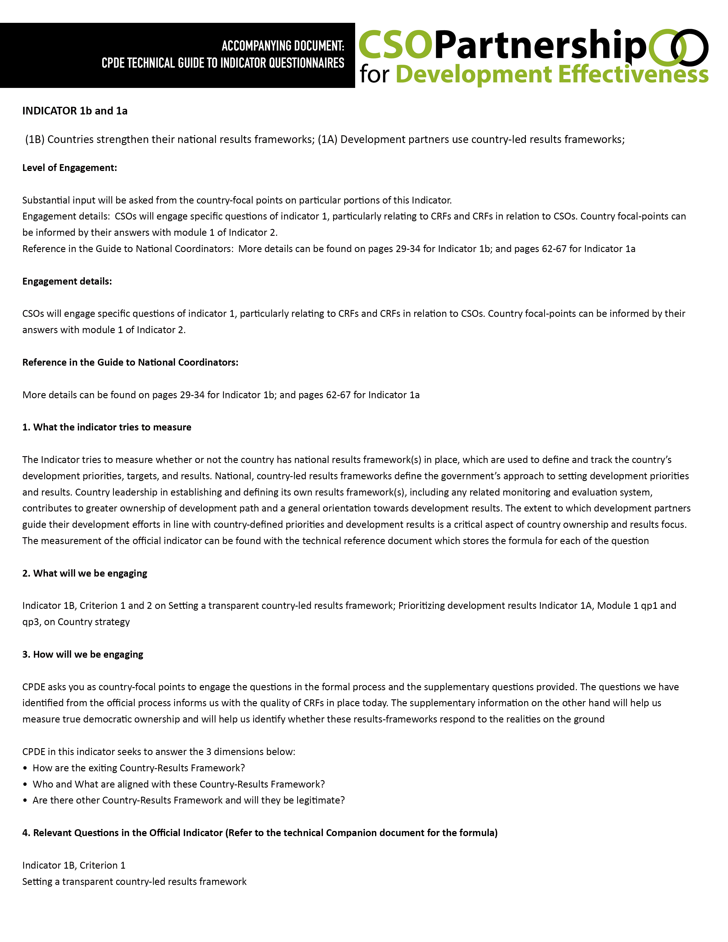

Qg1. Is there a national development strategy or government strategic plan?
YES
NO

If Yes, what is the name: Click here to enter text.

Qg2. To what extent did the following actors participate in developing the government strategy/plan?

Parliament [no/consulted/enacted the plan with a vote
Civil Society [no/consulted/participatory process
Private Sector [no/consulted/participatory process]
Subnational governments [no/consulted/participatory process]
Development Partners [no/consulted/participatory process]

Qg3. Is the strategy/plan publicly available online?

Yes
No
If yes, please include web link: Click here to enter text.

Indicator 1B, Criterion 2
Prioritizing development results
––––––––––––––––––––––––––––––––––––––––––––––––––––––––

Qg4. Does the national development strategy or government strategic plan define development priorities, targets and associated indicators?

Development priorities
Targets
Indicators

If targets and/or indicators are missing, can these be found in sector strategies and plans instead?

Yes
No

Qg5. How are the 2030 Agenda and SDGs incorporated or referenced in the development strategy or government plan? [Multiple answers among the following options]

The 2030 Agenda/SDGs are referenced at strategic level [in the narrative]
SDGs are referenced at goal level [in the narrative or result framework]
SDGs are referenced at target level [in the result framework]
Others
Please specify: Click here to enter text.

If there is no reference to the Agenda 2030 and the SDGs in the current strategy or government plan, or that document was approved before September 2015, is there an on-going process to incorporate SDG targets in the country’s strategic plans?

Yes
No

Qg6. If they exist, to what extent are sector and sub-national strategies linked to the national development strategy (e.g. timing and sequencing, consistency of their objectives, institutional responsibilities)? (SEE PICTURE BELOW)

Sectoral Subnational
Most sector/ Sub-nation al strategies are required to align to the national development strategy or government plan, by law and in practice.
Although there is no law, in practice central authorities (e.g planning, finance, development ministry) oversee that new sector/sub-national strategies align to the national development strategy or government plan.
Although there is no law or central authority enforcing alignment, sector/sub-national strategies tend to reflect at least core priorities in the national development strategy or government plan.
Only some sector/sub-national strategies are align with the national development strategy or government plan.
Sector/sub-national strategies are in general not aligned with the national development strategy or government plan.

Indicator 1A, Module 1
––––––––––––––––––––––––––––––––––––––––––––––––––––––––Qp1: At this moment, is there a country strategy or a partnership framework that guides external development interventions in the country?
Yes
No

If yes, have any of the following country-level stakeholders been engaged in the preparation?
Government
Civil society organisations
Private sector

Other stakeholders:
:Click here to enter text.

Has the national government signed off to the final document?
Yes
No

Indicator 1B, Criterion 2
Prioritizing development results
––––––––––––––––––––––––––––––––––––––––––––––––––––––––

Qp3: Does your country strategy include a results framework with strategic objectives, results indicators and targets to measure progress in achieving the objectives?
Yes
No

- If yes, how many results indicators are included?
:Click here to enter text.
- b. If yes, how many of these results indicators are drawn1 from the partner government’s results frameworks, plans and strategies?
:Click here to enter text.
- c. If yes, how many results indicators will be monitored using partner government official data and statistics?
Click here to enter text.

5. Additional Questions by CPDE
––––––––––––––––––––––––––––––––––––––––––––––––––––––––

CPDE Q1: Do CRFs recognize the existence of other RFs including those of CSOs?
Yes
No

CPDE Q3: DO CSOs development activities generally align with the CRF?
Yes
No

Comment: Click here to enter text.

INDICATOR 7
_________________________________________________________

Mutual accountability among development actors is strengthened through inclusive reviews

Level of Engagement:

Substantial input will be asked from the country-focal points on particular portions of this Indicator.

Engagement details:

CSOs will engage specific questions of Indicator 7, particularly relating to the policy framework and mutual dialogue. Country focal-points can be informed by their answers with module 3 of Indicator 2.

Reference in the Guide to National Coordinators:

More details can be found on pages 38-40

- What the indicator tries to measure
The indicator measures whether countries have established inclusive mutual assessment reviews, characterized by five dimensions: (i) a policy framework that defines the country’s development co-operation priorities; (ii) targets for the country and its development partners; (iii) regular joint assessment against those targets; (iv) active involvement of other stakeholders; and (v) public availability of the results of these reviews. The measurement of the questions of this indicator will be through a 4-level scale.

- What will we be engaging
Question 1 on policy framework, Question 4 on other actors, and Question 5 on public availability

- How will we be engaging
CPDE will be focusing its efforts on questions 1, 4, and 5. We will engage the policy framework of the CRF to measure the quality of development co-operation. Question 4 will then speak to mutual accountability while Question 5 will speak to Transparency and Accountability.

CPDE will be using the information gathered in this indicator to look at the quality of the mutual dialogue and the policy framework. Country focal-points are asked to complete the questions 1, 4, and 5, as well as CPDE’s supplementary questions.

- Relevant Questions in the Official Indicator

Qg1. To what extent is there a quality policy framework in place to guide development co-operation and partnerships?

Click here to enter text.

Qg4. To what extent have other development actors been involved in mutual assessments?

Click here to enter text.

Qg5. How soon are the results of such assessments typically made publicly available?

Click here to enter text.

- Additional Questions by CPDE
________________________________________________________

CPDE Q1: Do the policy frameworks recognize the role of CSOs as independent dev’t actors?

No
No, but they are being developed
Yes, but are seldom put into practice
Yes

CPDE Q2: Are representative CSOs generally invited to participate in mutual accountability assessments with other stakeholders?

Yes
No

Comment: Click here to enter text.

INDICATOR 8
________________________________________________________
Countries have transparent systems to track public allocations for gender equality and women’s empowerment (GEWE)

Level of Engagement:

High-level engagement on Indicator 8. This will involve country-level data gathering by focal-points.

Engagement details:

CSOs will engage the entire indicator including answering supplementary CPDE questions to inform GEWE

Reference in the Guide to National Coordinators:

More details can be found on pages 41-45

- What the indicator tries to measure:

The importance of this indicator is in establishing a policy framework with clear gender equality objectives; allocations in support of policy commitments; a system to track resource allocations; and, a mechanism to follow these allocations through to execution and impact. It also emphasizes the importance of making the data publicly available thereby strengthening oversight and accountability.

Under each of the criterion contains a set of questions to gauge the satisfaction of each criterion. Overall, When a country satisfies all criteria it will be classified as ‘fully meets requirements’. When a country satisfies one or two criteria it will be classified as ‘approaches requirements’. When a country does not satisfy any criteria, it will be classified as ‘does not meet requirements’.

- What will we be engaging:

Entire indicator which is composed of the 3 Criteria:
(1) On governments’ intent to address GEWE;
(2) Has mechanisms to track resource allocations;
(3) public availability of information

- How will we be engaging:

Country-focal points are asked to complete the whole indicator, which is composed of the 3 criteria, option questions, and additional questions by CPDE.

- Relevant Questions in the Official Indicator:

Part 5 on additional questions by CPDE have been adapted from the official questions, you may proceed to Part 5.

- Additional Questions by CPDE:
_________________________________________________________

Q. 1 Are there policies and/or programs of the government designed to close gender gaps / incorporate actions in SDG goals, where gender equality is not the primary objective?

Yes
No
Example or Explanation: Click here to enter text.

Q. 2. - Do policies and/or programs of the government, where gender equality is not the primary objective, have allocation within the budget sufficient to meet the gender equality goals?

Yes
No
Example or Explanation: Click here to enter text.

Q.3. Are there procedures in place to ensure that these resources are executed according to the budget?

Yes
No
Example or Explanation: Click here to enter text.

Q. 4 Are proposed gender impact assessments for key policies and programs in the budget include the participation of women’s organizations?

Yes
No
Example or Explanation: Click here to enter text.

Q. 5. Is the budget subject to Public discussions with participation of national and local women’s organizations to assess the extent to which it promotes gender-responsive policies?

Yes
Yes, but not the entire budget
No, the budget is not subject to public discussions
No, the budget is not discussed and there is no consultation
Example or Explanation: Click here to enter text.

Q. 6. How regular is the data on gender equality allocations being published?

twice a year
once a year
once every few years or irregular
never

Q. 7. What is the level of resources both in absolute terms (national currency) and as a percentage of total public expenditure, allocated to gender responsive policies and/or programs where gender equality is the primary objective, in the last financial year?

In absolute terms (national currency)
As percentage of total public expenditure

Q. 8 What is the level of resources both in absolute terms (national currency) and as a percentage of total public expenditure, allocated to gender responsive policies and/or programs where gender equality is not the primary objective in the last financial year?

In absolute terms (national currency)
As percentage of total public expenditure

INDICATOR 4
_________________________________________________________
Transparent information on development co-operation is publicly available

Level of Engagement:

Minimal portions of this indicator will be Included in the engagement

Engagement details:

CSO will engage this indicator by answering CPDE’s supplementary questions. These supplementary questions will extrapolate a CSO perspective on this largely government-centred indicator

Reference in the Guide to National Coordinators:

More details can be found on pages 74-78

- What the indicator tries to measure

The indicator measures whether information on development co-operation has been made publicly available at the global level. It is based on three different systems and standards that provide online data on development co-operation in an open and accessible manner. These are the OECD-DAC Creditor Reporting System (CRS), the OECD- DAC Forward Spending Survey (FSS), and the International Aid Transparency Initiative standard (IATI).

The country level element presents the percentage of development partners providing development co-operation that are included in a government’s management information system or other data management tools. This is calculated by dividing the number of development partners working in the country that are reflected in a country’s management information system or other data management tools by the total number of development partners working in the country.

- What will we be engaging

CPDE’s supplementary questions which draw their context from the official questions

- How will we be engaging

CPDE wants to assess whether CSO concerns are reflected in this indicator, particularly
if CSO concerns have access to this type of information and whether or not CSO
concerns are reflected in this type of information. CPDE will be utilizing the information
gathered in this indicator to assess if transparent information is accessible for CSOs to
determine if information is truly ‘transparent’

- Relevant Questions in the Official Indicator

NONE but CPDE supplementary questions are based on the official questions

- Additional Questions by CPDE

Q2 Do these management information systems cover or are sufficient in coverage of development cooperation for CSOs?

Yes
No

CPDE Q3: As CSOs, how accessible is public data to you?

No Access
Limited access but not workable information
Limited access but with workable information
Full Access

INDICATOR 9a
_________________________________________________________
Quality of Countries’ Public Financial Management (PFM) Systems;

Level of Engagement:

Minimal portions of this indicator will be Included in the engagement

Engagement details:

CSO will engage this indicator by answering CPDE’s supplementary questions. These supplementary questions will extrapolate a CSO perspective on this largely government-centred indicator

Reference in the Guide to National Coordinators:

More details can be found on pages 79-81

- What the indicator tries to measure

This indicator measures the quality of a country’s public financing management systems – including key aspects of budgeting, financial reporting, auditing and procurement systems. The indicator is based on the Public Expenditure and Financial Accountability tool (PEFA) that assesses public financial management performance. Achievement of national, regional and global development goals is contingent on country leadership in the implementation of development efforts. Government systems able to manage resources effectively and efficiently help ensure greater development effectiveness.

- What will we be engaging

CPDE’s supplementary questions which draw their context from the official questions

- How will we be engaging

CPDE needs to determine whether or not CSOs are engaged in budget related concerns. CPDE’s supplementary question will gauge CSOs’ involvement in the PEFA process, public consultation for budget, and access to information. CPDE aims to assess whether consultations for budget excludes CSOs, information is available for CSOs, or if CSOs are included in the planning process as well

- Relevant Questions in the Official Indicator

NONE but CPDE supplementary questions are based on the official questions

- Additional Questions by CPDE
_________________________________________________________

CPDE Q1: Are CSOs engaging the PEFA process?

Yes
No

CPDE Q2: Are CSOs at the national level engaging in public consultation for budget

No, there is no consultations
No, there are public consultations but no space is given for CSOs
Yes, but with very limited engagement of CSOs
Yes, with satisfactory and/or genuine engagement of CSOs

CPDE Q3: Do CSOs have public access to physical information on budget?

No Access
Limited access but not workable information
Limited access but with workable information
Full Access

CPDE Q4: Do medium-size/large CSOs generally engage auditors?

Yes
No

